



ADVANCED SPREADSHEET APPLICATIONS
(235)

STATE 2024

PRODUCTION
Job 1: Format Spreadsheet/Queries/Advanced __________ (125 points)
Functions
Job 2: Subtotaled List and Advanced __________ (75 points)
Functions
Job 3: Create and Modify Chart __________ (75 points)
TOTAL POINTS __________ (275 points)

Test Time: 90 minutes

GENERAL GUIDELINES:
Failure to adhere to any of the following rules will result in disqualification:
- Member must hand in this test booklet and all printouts if any.
- No equipment, supplies, or materials other than those specified for this event are allowed in the testing area. No previous BPA tests and/or sample tests (handwritten, photocopied, or keyed) are allowed in the testing area.
- Electronic devices will be monitored according to ACT standards.

EXAM GUIDELINES:
- Ensure this test booklet contains Jobs 1-3.
- Key all jobs according to the instructions given.
- Correct any and all formatting, spelling or grammar errors. Use the formatting guide in the Style & Reference Manual.
- Your name or initials should not appear on any work you submit. Use your Member ID in any occasion you would normally key your reference initials.
- In the lower right hand corner of ALL work submitted (unless otherwise specified), key your Member ID and job number.
- If you complete the event before the end of the time allotted, notify the proctor. Time may be considered a factor in determining a winner when there is a tie score.
- Place your scoring sheet on top of your jobs. Jobs should be placed in numerical order.

Job 1 (Format Spreadsheet/Queries/Advanced Functions) | Points Possible | Points Earned
Member Number and Job Number in right section of footer | 5
Format Cell A1 with Heading 1 cell style | 5
Merge Cell A1 across columns A-G | 5
Format data in column A with date format dd-mmm (01-Jan) | 5
Format Cells A3-D70 as a table, using Green, Table Style Dark 11 (should have drop-down lists in column headings) | 10
Using Queries feature, create a query, bringing in data from provided text file. | 10
Rename columns in Sheet2 to City, County, and Avg Home Price | 5
In Sheet1, insert two columns between columns C and D. Name new columns “County” and “Avg Home Price” | 10
Column D has VLOOKUP function to insert county from Sheet 2, column D | 10
Column E has VLOOKUP function to insert average home price from Sheet 2 into Column E | 10
All 6 instances of Sioux Falls in column C is linked to webpage https://www.siouxfalls.org | 10
Add column heading to column G, “Price Compared to Avg Home Price,” and insert formula B4-E4 to cells in column G | 10
Use arrow icons in column G to indicate a green “up” arrow for any cell that is greater than or equal to 0. Cells that are less than 0 should not show any arrows. | 10
Print data in portrait orientation, fitting all columns to one page | 10
Hide all columns except column D, and print again, showing formulas, in landscape, resizing column D so that entire VLOOKUP function is visible | 10
Subtotal | 125

Job 2 (Subtotaled List and Advanced Functions) | Points Possible | Points Earned
Member Number and Job Number in right section of footer | 5
Unhide all columns from Job 1 spreadsheet | 5
Sort data by County (ascending), then by Property Location (ascending), and then by Listing Price (descending) | 15
Convert the table to a range (it will no longer have the drop-down list arrows in column headings) | 10
Use Subtotal feature to group and calculate the average Listing Price by County. Include Grand Average at bottom | 20
Format font for subtotaled averages and grand average in Accounting format, with a dollar sign, 0 decimal places, bold | 15
Print worksheet in portrait orientation showing data, scaling to fit all columns on one page | 5
Subtotal | 75

Job 3 (Create and Modify Chart) | Points Possible | Points Earned
Member number and job number in right section of footer | 5
Filter data to select only six cities (Aberdeen, Germantown, Harrisburg, Mitchell, Rapid City, Sioux Falls) | 10
Create 3D Clustered Bar chart, using Style 3, using County and Avg Home Price | 15
Place chart on separate sheet in workbook, resize to fit Cells A1-K22 | 10
Change chart title to AVERAGE HOME PRICE BY COUNTY | 5
Format text outline to solid line, 0.5 width (will affect legend labels) | 10
Change chart style to 5, showing data across bottom of chart | 10
Print chart in landscape orientation, centering horizontally and vertically on page | 10
Subtotal | 75
TOTAL POINTS | 275

Job 1: Data in portrait orientation, fitting all columns to one page
Format should appear as below in pdf
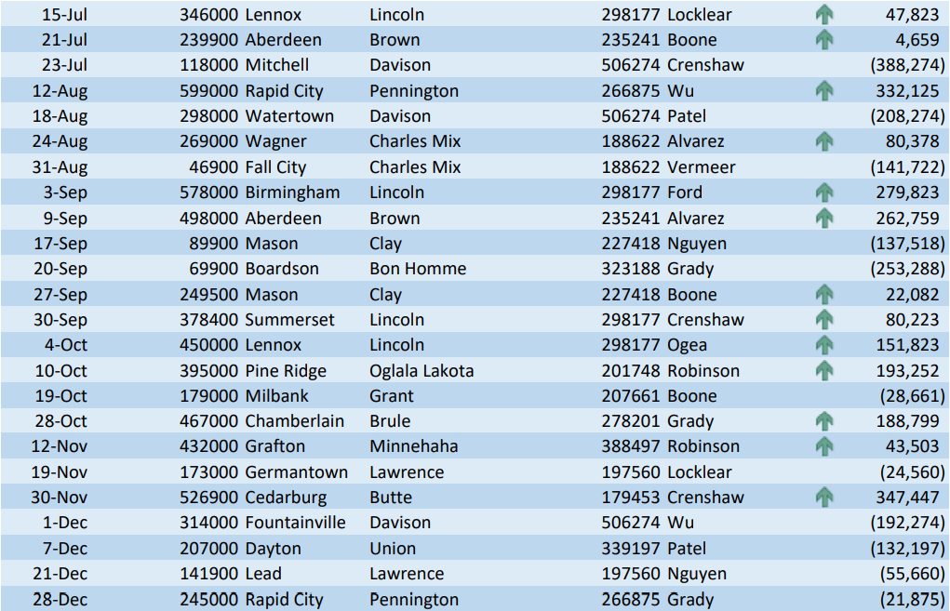

JOB 1 – Formulas in landscape orientation, showing entire VLOOKUP function in column D (other columns hidden)

County
=VLOOKUP([@[Property Location]],City_CountyData,2,0)
=VLOOKUP([@[Property Location]],City_CountyData,2,0)
=VLOOKUP([@[Property Location]],City_CountyData,2,0)
=VLOOKUP([@[Property Location]],City_CountyData,2,0)
=VLOOKUP([@[Property Location]],City_CountyData,2,0)
=VLOOKUP([@[Property Location]],City_CountyData,2,0)
=VLOOKUP([@[Property Location]],City_CountyData,2,0)
=VLOOKUP([@[Property Location]],City_CountyData,2,0)
=VLOOKUP([@[Property Location]],City_CountyData,2,0)
=VLOOKUP([@[Property Location]],City_CountyData,2,0)
=VLOOKUP([@[Property Location]],City_CountyData,2,0)
=VLOOKUP([@[Property Location]],City_CountyData,2,0)
=VLOOKUP([@[Property Location]],City_CountyData,2,0)
=VLOOKUP([@[Property Location]],City_CountyData,2,0)
=VLOOKUP([@[Property Location]],City_CountyData,2,0)
=VLOOKUP([@[Property Location]],City_CountyData,2,0)
=VLOOKUP([@[Property Location]],City_CountyData,2,0)
=VLOOKUP([@[Property Location]],City_CountyData,2,0)

All rows will have the same formula.

JOB 2 – Data printed in portrait orientation, scaling to fit all columns on one page.

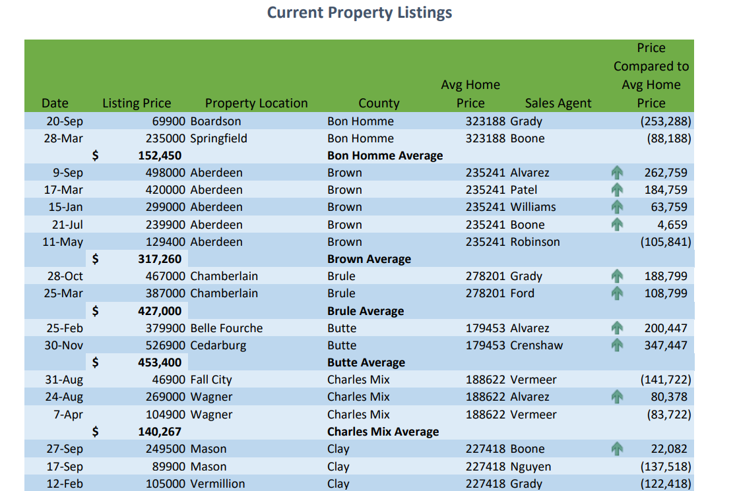
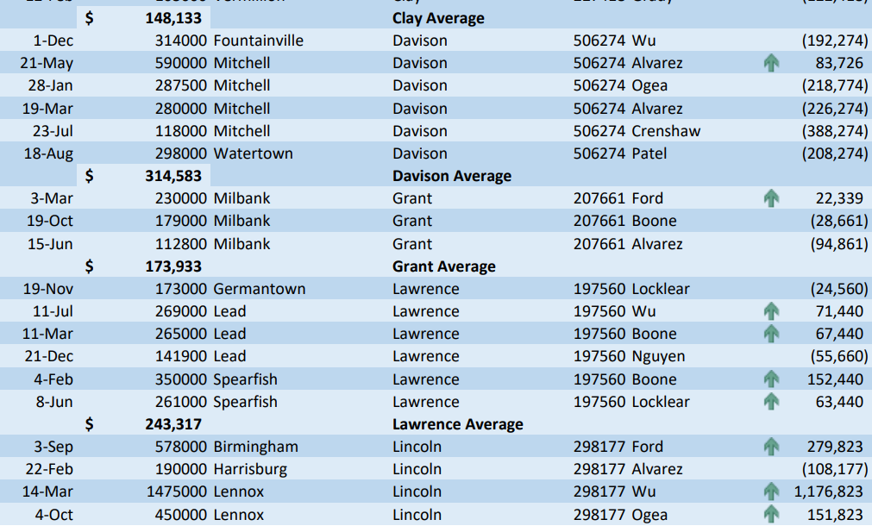

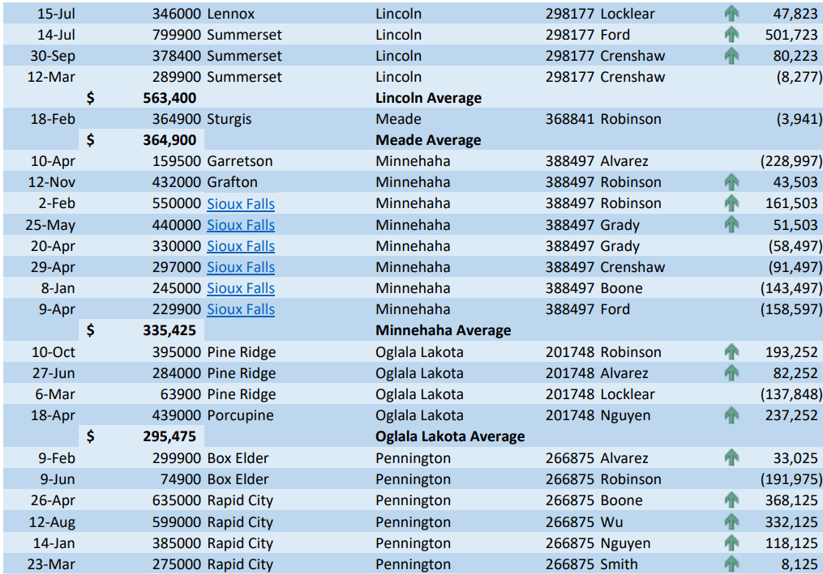
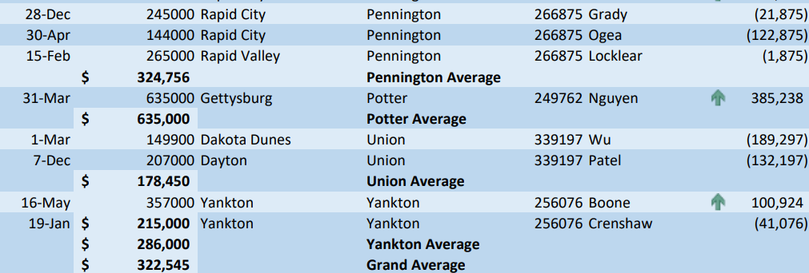

JOB 3 – Chart printed in landscape orientation and centered horizontally and vertically in approximate size as shown here.

